EDUCATION LOAN SECTION
Serial No…………………………
AG’S BRANCH
EDUCATION LOAN

APPLICATION FORM – OFFRs, JCOs/OR

IC/JC/Army No _____________________ Old Army No ________________________

Rank __________________ Name _________________________________________
(in capital letters)

Mobile No _____________________ E-Mail __________________________________

Serving with full Address ________________________________________________

________________________________Parent Unit ____________________________
(In case of Staff/ERE/Deputation)
Permanent Home Address_______________________________________________

______________________________________________________________________

(Revised Format as on 25 May 2022)

INDEX

1. Highlights of the Scheme - I

2. Eligibility Conditions - II

3. Instructions/Guidelines for Filling of Application Form - III

4. Check List - IV

5. Blank Application Form - 1-4

6. Undertaking Certificate - 5

7. NACH Mandate Form - 1

Not to be submitted with Application Form

I

HIGHLIGHTS OF THE SCHEME

1. UPPER LIMIT - Rs 5,00,000/-.
2. INTEREST RATE - 7% P.A.
3. EFFECTIVE ROI - 3.5 TO 3.8%.
4. DURATION - MAX 5 YEARS OR SIX MONTHS BEFORE RETIREMENT (WHICHEVER IS EARLIER)

5. REPAYMENT MODE - EMI (ECS MANDATE TO BEGIN WITH,
LATER THROUGH CDA(O)/PAO(OR)

WEB-VERSION OF APPLICATION FORM AVAILABLE ON THE FOLLOWING LINK:-
https://portal.army.mil/watermark/download.php?download:links/watsnew/Apr_ whatsnew/edn loan application 01 apr2022ammended.pdf

Not to be submitted with Application Form

II

ELIGIBILITY CONDITIONS

1. Following are eligible:-

(a) Serving Personnel ( Re-employed are not eligible).
(b) Wards of Serving Personnel.
(c) Dependent Sister.

2. Loan can be taken for Govt Recognised Colleges/Universities/Institutions for under Graduate/Post Graduate/ Professional Studies/Course.

3. Quantum of loan is based on repaying capacity, residual service and fee structure schedule of College/Universities/Institutions.

4. Loan will be disbursed in one instalment in case the total fees is equal or more than Rs 5 lakhs.

5. Loan is admissible for higher education in India as well as abroad.

6. In case of retirement/release/invalidment of the member before repayment of the loan, the outstanding amount together with due interest is to be refunded by the borrower well in time failing which, it would be recovered in one lump sum out of his survival/retirement benefits etc with interest.

7. In the event of death while in service, the outstanding balance thereon would be recovered from the survival benefits, admissible to Next of Kin.

8. In case of deputation, outstanding balance of loan must be refunded to ELS before going on deputation.

Not to be submitted with Application Form

III

INSTRUCTIONS FOR SUBMISSION OF APPLICATION FORM
(TO BE DETACHED AND SUBMITTED BY APPLICANT)

Instructions/Guidelines for Filling of Application Form
1. Application to be filled in BLOCK CAPITALS.
2. If being handwritten, please use black ball point pen for filling
3. Tick boxes where applicable.
4. Attach relevant documents wherever indicated.
5. All serials to be filled. Application likely to be rejected if left blank.
6. Filled application form to be sent by registered post to AGs BRANCH EDUCATION LOAN SEC, ROOM No 17B, WEST BLOCK III, RK PURAM, NEW DELHI-110066

7. The application form is to be clearly filled in single copy after ensuring eligibility for loan as per rules. Cross out all the words which are not applicable.

8. Officer should mentioned their earlier SS/MS personnel numbers and Old Army No must be filled by all SC/SL Officers & JCOs. In case the old Army No is left vacant the application will be returned back.

9. Maximum permissible Education Loan is Rs 500000/- (Rupees Five Lakh only).

10. The application is required to be countersigned by CO/OC Unit/Director concerned (If posted in IHQ of MoD (Army).

11. EMI once fixed will not be changed.

12. Commissioning to Officer from JCOs/OR. On commissioning to Officer from JCOs/OR, Education Loan Sec will be intimated for updation of record.

13. The term OC unit denotes OC of an independent self accounting unit only and not a sub unit Commander of a Major Unit.

14. The rate of interest will be 7% per annum.

15 Mode of Disbursement. Through NEFT. Payment will be made only on receipt of a cancelled cheque alongwith complete Bank address, Account Number, IFS Code and MICR Code.

16. Payment/Deduction of EMI. The EMI for repayment of the principal and interest on loan once fixed will not be altered. Till mandate for deduction of EMI through CDA(O)/ PAO(OR) is not received from the Government, EMIs will be deducted through ECS mandate. Applicant to submit ECS mandate form from his/her salary bankers along with six signed crossed blank cheques in favour of ACWF (ELS) leaving the amount and dates blank.

17. Documents to be enclosed alongwith Application Form. All the documents will be enclosed as per check list.
Not to be submitted with Application Form

18. Application form should be forwarded under unit covering letter
IV

CHECKLIST OF DOCUMENTS TO BE SUBMITTED ALONGWITH THE APPLICATION

Ser No | Action/ Documents
1. | Self attested copy of PAN Card of Applicant
2. | Self attested copy of AADHAR Card of Applicant
3. | Self attested copy of AADHAR Card of Ward
4. | Copy of Part II order of Ward
5. | Self attested copy of latest pay slip
6. | Self attested copy of Admission Letter of College/University/ Institution where admission is being sought
7. | Copy of letter showing Breakdown of Fee/ Expenditure where admission being sought
8. | Cancelled cheque of DSP account
9. | Six post dated crossed cheques duly signed by account holder in favour of “Army Central Welfare Fund (Education Loan Section)”. (Leave the date and bank amount blank).
10. | Undertaking duly signed by Borrower and NOK, countersigned by CO/ Head of the Office
11. | NACH mandate form duly signed by the indl concerned (at primary applicant only on all three forms). The signatures should match with DSP Acct

LOAN APPLICATION FOR OFFRS AND JCOS/OR
(Revised Format as on 25 May 2022)

Latest PP Size photo of applicant duly attested by CO/OC
Latest PP Size photo of ward duly attested by CO/OC

PARTICULARS OF APPLICANT

1. IC/JC/ Army No -
(Note: whichever applicable)

2. Rank -

3. Full Name -

4. Date of Commission/ -
Enrolment

5. Date of Birth -

6. Extn Gtd/ Not Gtd -
(For JCOs/NCOs only)

7. Date of Retirement -
(In present rank)

8. Present Unit/ Parent unit -
(If on ERE both the units to be mentioned)

9. Formation -
(mention immediate and superior Formation HQ)

10. CDA(O)/PAO -
(mention relevant paying authority)

11. CDA(O) Acct No -
(In case of Offr)

12. PAN Card No -

13. Aadhar Card No -

14. Permanent Address - ____________________________________
(Attach proof of residence Aadhar/ ____________________________________
Voter ID/ First page bank pass book) ____________________________________
____________________________________

15. Mobile No -
(Should be linked with Bank account)

16. Email Address -
(Mandatory)

2

17. Details of Bank Account. (Salary Account details to be submitted)

(a) Account No -

(b) IFSC Code -

(c) Branch Address - ____________________________________
(Attach cancelled cheque) ____________________________________
____________________________________
____________________________________

KYC DETAILS OF STUDENT ( for whom loan being applied)

18. Name (in full) -

19. Gender -

20. Date of Birth -
(Attach self attested copy of Part 2 order)

21. Relationship with Applicant -

22. Father’s Name -

23. Mobile No -

24. Email address -

25. Identification Proof -
(Self attested copy of PAN Card/Aadhar Card/Voter I Card/Passport/DL)

26. Education qualification -
(Attach self attested marksheet)

3

FINANCIAL DETAILS OF APPLICANT

27. Salary details -
(attach latest pay slip)

28. Current Loans (if any) -
(if Yes, please give details of loan taken, amount, source and EMI)

29. Any other source of Income-
(Please indicate amount and source)

30. Whether availed Education -
Loan for other children?
(if Yes, submit details of loan amount, source and EMI)

31. Details of Movable and -
Immovable property held
in the name of the Applicant
(Give details of Cash in bank, FDs, Shares
and debentures, DSOPF/AFPF, Immovable
property etc)

DETAILS OF THE COURSE/STUDY (FOR WHICH LOAN BEING APPLIED)
(submit copy of admission letter with breakdown of expenditure)

32. Name of the Proposed Course of Study -

33. Name of the Institution, University, Country -

34. Reasons for selection of Institution / University -

35. Ranking of the Institution or course -

36. Duration of course /study -

37. Date of commencement of course -

LOAN REQUEST
38.
Cost of the Course |  | Source
(a) Tuition fees |  | (a) Details of non repayable studentship / fellowship, etc. available to the Student | -
(b) Essential Books, Stationery, equipments, |  | (b) Details of repayable studentship / fellowship, etc. available to the Student | -
(c) Examination Fees |  | (c) Details of funds available from own and family sources for the course
(d) Maintenance Expenditure |  | (d) Amount of loan applied for
(e) Miscellaneous
TOTAL (SHOULD TALLY WITH COST) |  | TOTAL (SHOULD TALLY WITH COST)

4

DECLARATION

I, No _____________ Rank _______ Name _________________ hereby apply for edn loan from AGs Branch Education Loan Section and I, declare that the foregoing particulars and information furnished in this application form are true, accurate and complete.

I WILL BE FULLY RESPONSIBLE AND LIABLE TO RE-PAY THE LOAN AMOUNT DUE TO ANY CHANGES OCCURRING IN DEPENDENCY OF MY WARDS/SPOUSE FOR WHOM I AM APPLYING FOR EDUCATION LOAN. I ALSO GIVE MY CONSENT TO __________________________________________________________________ (mention your Bank Account No and Name of Bank where salary is credited) DEDUCT THE EMI THROUGH NACH DIRECTLY FROM MY BANK ACCOUNT.

I further declare that I will not change my Salary Bank Account without obtaining NOC from Education Loan Section and I will inform Education Loan Section regarding change of my correspondence/ permanent address and unit.

---------------------------
(Signature of Applicant)

COUNTERSIGNED BY CO/OC UNIT

Certified, that I have perused the application and the details furnished by the applicant are true to the best of my knowledge.

(Countersigning Authority to mention his/her name, contact No and email address alongwith official seal and stamp)

5

UNDERTAKING BY NO ___________ RANK ______ NAME ___________________ OF UNIT _______________ TO SET-OFF OUTSTANDING EDUCATION LOAN AMOUNT OUT OF MATURITY BALANCE DUE FROM ARMY GROUP INSURANCE FUND

I, No ______________ Rank _________ Name _________________ Unit ________ hereby voluntarily permit and authorize Army Central Welfare Fund (Education Loan Section) and Army Group Insurance Fund to set-off outstanding education loan and interest amount out of maturity balance due from Army group Insurance Fund in the event of my becoming non-effective in Indian Army for any reasons.

Signature of Applicant _____________ Signature of NOK __________________
Date : Name ___________________________
Unit : Relation _________________________
Age ____________________________

COUNTERSIGNED BY HEAD OF THE DEPARTMENT

Date :
Unit Stamp :
Unit seal afficial stamp of the countersigning authority giving details of Rank, Name, Appointment, Email address and Contact Number
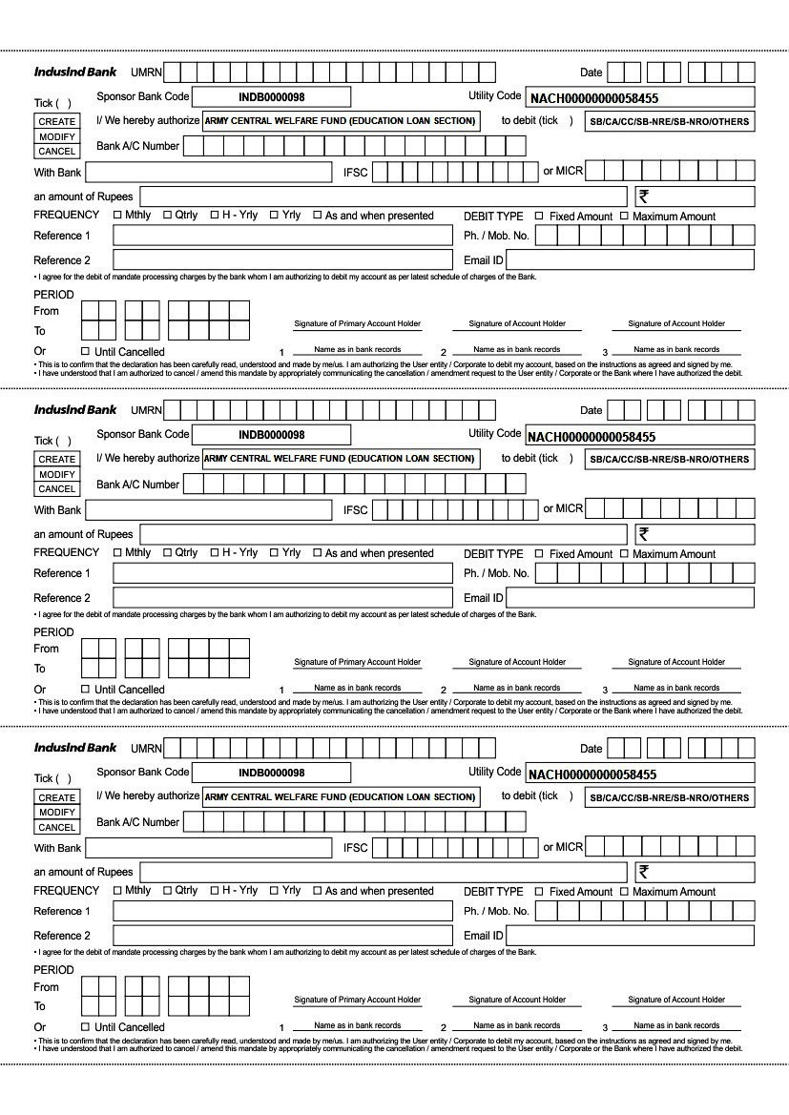
NACH MANDATE FORM

INDIAN ARMY
EDUCATION LOAN SCHEME

- HIGHLIGHTS OF THE SCHEME:-

- FOR SERVING PERS/ THEIR WARDS/ DEPENDENT SISTER PURSUING UNDER GRADUATE/ POST GRADUATE STUDIES IN GOVT RECOGNISED COLLEGES/UNIVERSITIES/INSTITUTIONS.

- UPPER LIMIT - Rs 5,00,000/-.
- INTEREST RATE - 7% P.A.
- EFFECTIVE ROI - 3.5 TO 3.8%.
- DURATION – MAX 5 YEARS OR SIX MONTHS BEFORE RETIREMENT (WHICHEVER IS EARLIER)

- REPAYMENT MODE - EMI (ECS MANDATE TO BEGIN WITH.
LATER THROUGH CDA(O)/PAO(OR)

- COLLATERAL SECURITY - NIL

- MORATORIUM PERIOD - NIL

- CONCURRENT LOAN - LOAN CAN BE AVAILED FOR SECOND CHILD/WARD SUBJECT TO REPAYMENT CAPACITY.

- DOWNLOAD APPLICATION FORM FROM:-

https://portal.army.mil/watermark/download.php?download:links/watsnew/Apr_what snew/edn loan application 01 apr2022ammended.pdf

- FOR FURTHER DETAILS, CONTACT:-
- E-MAIL – agbrloansec@gmail.com
- ARMY TELE – 34499
- CIVIL TELE – 011-20863017
- ADDRESS - EDUCATION LOAN SECTION
ADJUTANT GENERAL’S BRANCH
INTEGRATED HQ OF MoD (ARMY)
ROOM NO 17B, WEST BLOCK-III
RK PURAM, NEW DELHI-110066

INDIAN ARMY
EDUCATION LOAN SCHEME

COMMON MISTAKES OBSERVED IN APPLICATION FORMS

- Following common mistakes have been observed while processing the application received to date:-

- Countersignatures. Applications are not being countersigned by CO even though the unit is being commanded by a CO. OC Unit can only countersign in case of an independent entity.

- Details of Countersigning Authority. Applicants are not submitting the details of countersigning authority like, name, e-mail address and contact number.

- Non-submission of Other Loan Details. Applicants in some cases have not submitted details of other loans with EMI, if taken.

- Non-submission of Proof of Admission in College/Institutions. Applicants in some cases have not submitted course offer letter with duration as proof of Admission from the concerned College/Institute.

- Non-submission of Proof of Expenditure. Applicants having incurred expenses towards Laptops, Books etc are not submitting proof of purchase.

- Hostel Expenditure. Applicants are not submitting hostel expenditure fees receipt nor rental/lease agreement in case of staying under private arrangements.

- Non-submission of College Fee Breakdown. Applicants in some cases have not submitted fee structure from college/Institute where admission granted.

- Non-submission of copy of CIBIL Score. Applicants in some cases have not submitted copy of CIBIL score.

- Non-submission of 06 x Post-dated cheques.

(i) Applicants in some cases have not submitted 06 x post-dated cheques of DSP account duly signed in favour of “Army Central Welfare Fund (Education Loan Section)”.

(ii) Applicants in some cases have submitted post-dated cheques issued by their previous bank branch. Cheques should only be from applicant’s present branch where salary credited.

- Submission of NACH Mandate Form. Applicants are required to fwd NACH mandate form duly signed at Ser No 1 (Signature of Primary Account Holder) only, and no other details are required to be filled in the form.

